Expt No. 7
Process Control Simulator

1. Introduction

The Process Control Simulator PCS327 is a special-purpose analogue simulator employing integrated circuit operational amplifiers. Number of variable interconnections together with a range of non-linear functions permit a detailed study of the dynamic responses of a wide variety of linear and non-linear processes and the application of proportional, integral, derivative, two-step, three-step (with and without overlap) and many other modes of control. Provision is made for the process characteristics and controller configuration to be preset.

2. Functional Description

Fig.1 shows the panel layout. A power on-off switch and indicator lamp are mounted on the left-hand side of the case. Range of all input and output signals is ± 10V.

The Simulated Process

The process comprises the following elements, any of which may be inserted or omitted from a complete process by the use of jumper leads.

1 Simple lag of time constant 10 milliseconds or 1s
2 lags of time constant 10millseconds or 1s (each convertible by toggle switches to integrators of time constant 10 ms or 1s)
1 distance- velocity lag of delay 10 milliseconds or 1 second, selected by a toggle switch
1 inverter

The time constants of all the above elements can be set by one toggle switch to slow (1s) or fast (10ms) mode. With these elements any of twelve different linear process characteristics of Type 0, 1 and 2 may be established. Every element produces a polarity inversion but the inverter may be included or not as necessary to produce the desired overall polarity.

The Simulated Controller

The controller is of the PID type which generates a control signal of the type

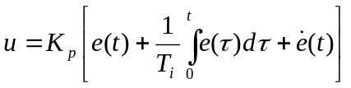
The Controller comprises the following elements:
1 Set-value control of range ± 10 volts
1 Comparing element
1 Integral action control scaled in integral action time T_{i}
1 Derivative action control scaled in derivative action time T_{d}
1 Proportional band control scaled in % proportional band PB=100/K_{p}

The comparing element generates the deviation as the difference between the controlled condition and the set value and passes it to the three–term controller comprising the integral, derivatives, and proportional controls.

To avoid problems due to integrator drift an OFF position is provided on the integral action control in which the integral term at held at zero.

Non-linear unit

This provides a selection of idealized but typical non-linear characteristics. The location of the element is chosen (between the controller output and process input) to permit it to be considered in either of the two following lights as

- Representing typical mechanical non-linearities such as backlash, hysteresis, deadband, etc or
- Occurring in any of the motor, correcting, measuring or detecting elements, as representing various types of non-linear controller characteristic, e.g two-step with or without overlap.

The nonlinear element comprises:

switch selector

limits control

deadband control

overlap control

The various forms of non-linearity provided, with the effects of three controls and the applications under (a) and (b), are fully explained by figure 2 and need no further comment except that the backlash characteristic is valid for only a limited range of signal frequencies; 3 to 60Hz in the FAST (10ms) mode and 0.03 to 0.6Hz in the SLOW (1s) mode as determined by the controller speed selection switch.

Meter Indicator: two center-zero meters indicate the set value (lower meter) and either the measured value or the deviation (upper meter} according to the switch position selected. The sense of the meters is arranged to ensure correct polarities according to the equation

Deviation = Measured Value - Set Value

Interface Units: Two voltage –to-current and one current –to-voltage converter are provided to permit either the Process or the Controller to be replaced by external equipment operating within the standard 4-20mA current range. The second V-I circuit may be used for connection of a current operated chart recorder if desired.

3. Setting up a Process:

To set up a process simply patch the required elements (shown on the top row of Fig, 1) in cascade, with the first input patched from the supply disturbance summing element output (node A) and the last output patched to the load from the disturbance summing element input (node C). The inverter is included or not as necessary to ensure that the total number of polarity inversions round a closed loop is always odd. To simplify this, every element which produces an inversion is already marked to show the relative polarities of input and output. Summing points are indicated as usual as circles with + and – symbols inside.

Notice that for a summing point to behave as if it produced a difference (as required to generate the deviation term) it is sufficient for there to be an odd number of inversions in the loop (including the one produced by the summing point), overall negative feedback. We consider a process containing two simple lags and an integration. The patching would be as in Fig1. Without the inverter there will be seven inversions around the loop formed when the controller is patched in. Since this is an odd number, the inverter is not required.

Experiment 1: Proportional Control System Response

Refer to Fig 1. Connect the jumper E to H to apply proportional control. Inject into the system at point A a square wave signal 5V p-p at 0.05Hz. As the input disturbance are applied compare the reading of the MEASURED and SET VALUE meters. Alternatively display on an oscilloscope the SET VALUE DISTURBANCE from point X and the negative MEASURED VALUE from the point B, with both PROCESS and CONTROLLER switches at FAST, and input signal frequency 1.0Hz. Switch the meter to DEVIATION or display from point C and note changes in DEVIATION as disturbances are applied. Note final setting points of both MEASURED VALUE and DEVIATION. Repeat all the above tests with a percentage PROPORTIONAL BAND set at 50 and then 5.

Summary: As each step is applied the system responds as shown below.

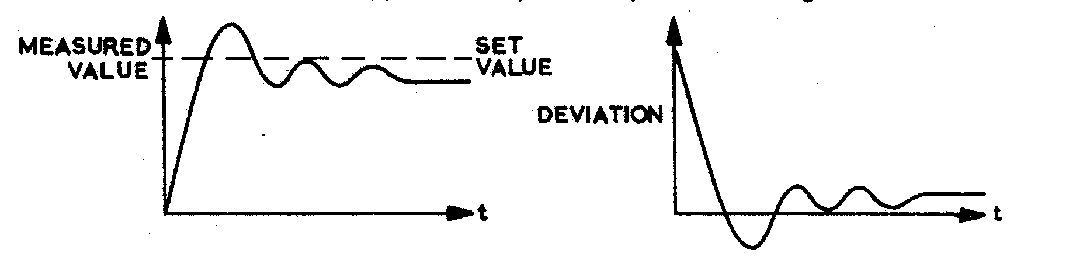

The system moves slowly towards the SET VALUE. When it has there exists a considerable DEVIATION. As the percentage PROPORTIONAL BAND is reduced, i.e, the gain of the system is increased, the steady state DEVIATION is reduced and the system settles with its MEASURED VALUE much closer to the SET VALUE. In order to reduce the steady state DEVIATION to zero, however, the gain must be increased to such a value that the system becomes completely unstable. A compromise gain level must be used which maintains, a steady state deviation signal.

Experiment 2 Proportional Plus Integral Control:

Set all switches and control as in Experiment 1. Connect the jumper D to G for integral action. Apply to the SET VALUE DISTURBANCE socket X a square wave of 5V p-p or 1.0 Hz. Adjust the proportional band control to 50 and adjust it until the system settles with about four overshoots only after each disturbance. Continuous oscillation should commence at a value of about 12. Monitor DEVIATION socket C and slowly reduce the setting on INTEGRAL ACTION control until DEVIATION falls to zero after each disturbance. Note the number of overshoots before it settles. Note the output of the integrator socket D when the system has settled. Note the difference between MEASURED and SET VALUE. Reduce INTEGRAL ACTION control to 10 and note the responses of system.

Summary: By suitable adjustment of the integrator time constant the steady state DEVIATION can be reduced to zero. In consequence the MEASURED VALUE becomes much closer to SET VALUE. Too much integral term however causes the system to go into oscillation. Generally speaking an increase in the integral term reduces steady state deviation but increases the time the system takes to settle.

Experiment 3: Proportional + Integral+ Derivative Control:

Derivative Control: As was seen in Experiment 2 integral control improves the performance of the control system in some respects, i.e., reduces steady state DEVIATION, but has the disadvantage of slowing down the overall response time. If a system was required to follow a sudden change in SET VALUE this would give rise to rapid change in the DEVIATION. Although this deviation change is rapid the system responds rather slowly, so if at this time controller output could be boosted the speed of system response could be improved. If the deviation was differentiated i.e. its rate of change measured, and a signal produced proportional to this and then added to the signals from the proportional and integrator sections, some improvement should result.
Set all switches and controls as in Fig l connect the jumper for all the control actions. Apply to the SET VALUE DISTERBANCE socket a square wave input of 5V p-p or 1.0Hz. Adjust INTEGRAL ACTION until steady state deviation is zero. After a disturbance note the steady state deviation and number of overshoots before the system settles. Slowly increase the DERIVATIVE ACTION control and note the effect this has upon the system response. Also check if this has any effect upon this steady state DEVIATION.

Summary: Application of the DERIVATIVE TERM does not have any effect upon the steady state deviation but does reduce the settling time by reducing the number of oscillation.

Experiment 4: Adjustment of 3-Term Controller

Use the same circuit arrangement as for experiment 3. Set the INTEGRAL ACTION TIME and DERIVATIVE ACTION TIME to OFF and 0 respectively with percentage PROPORTIONAL BAND 100%. Apply step input disturbance as before and adjust INTEGRAL ACTION TIME until steady state DEVIATION is zero. Increase the DERIVATIVE ACTION until the MEASURED VALUE shows no signs of oscillation. Reduce the percentage PROPOTIONAL BAND until the best response of MEASURED VALUE can be obtained giving minimum overshoot and oscillation.

Additional Experiments: If you have time, study the effect of adding various types of nonlinearities shown in Fig. 2 on the closed loop behaviour of the process under P, PI and PID control.
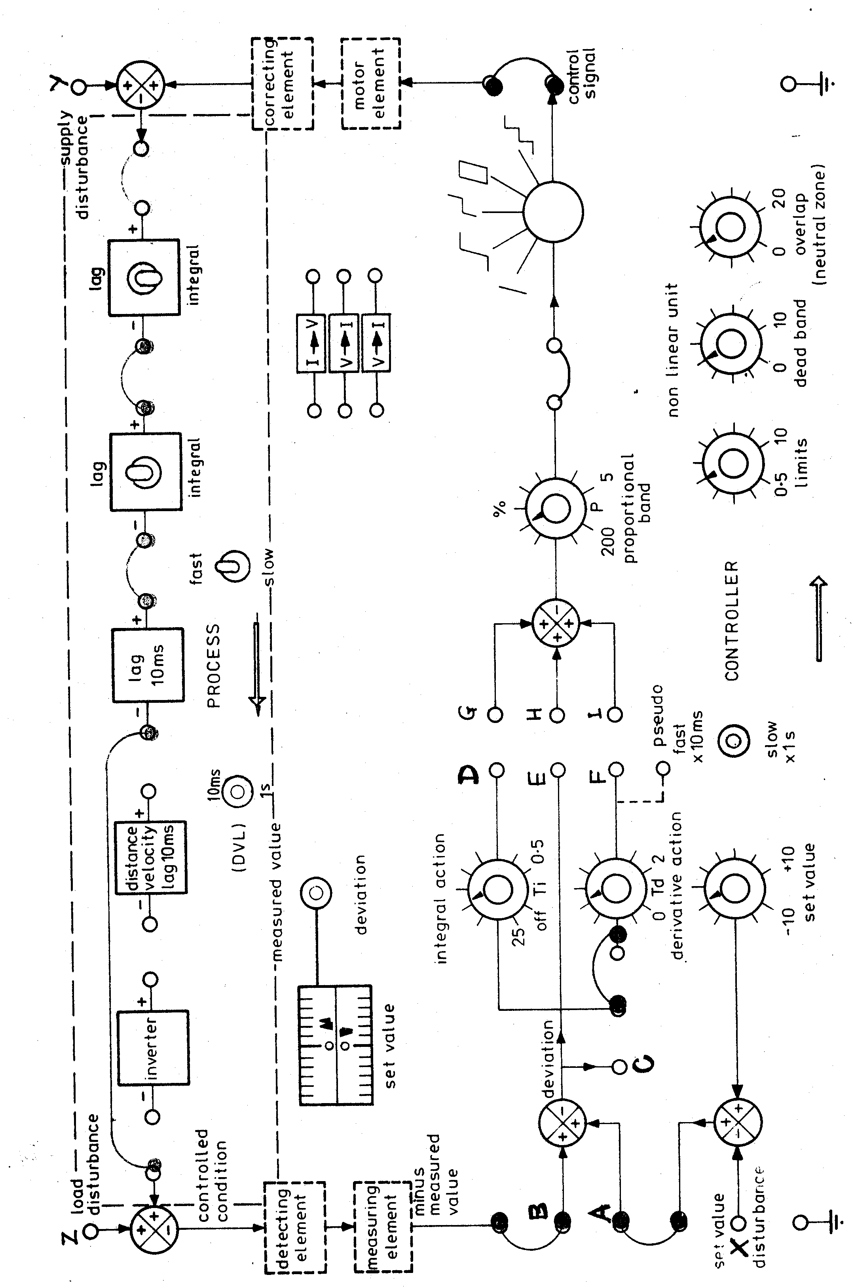

Fig.1. Connection Diagram for the Process Control Simulator
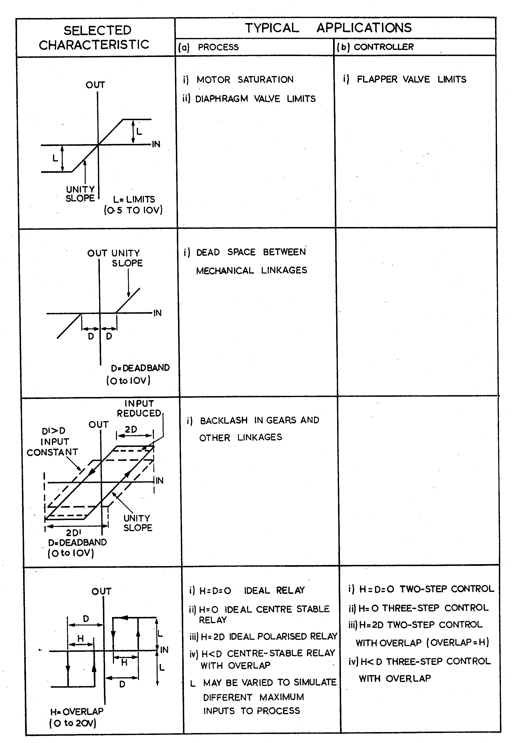

Fig.2. Typical Nonlinearities simulated on the Process Control Simulator

